(Array Operations)

Name: Anuj Solanki

Register No: 20218411

Q.1. create two arrays with following values:

First = 9 8 7

6 5 4

3 2 1

second = 11 2 44

53 7 55

34 90 67

Perform all the comparison operations on the arrays:

Code:

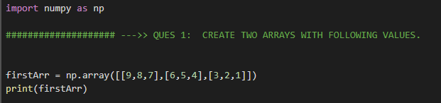

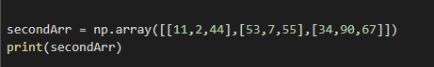

OUTPUT:

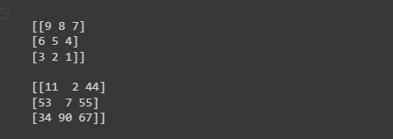

Q.2. Display the size, shape and dimensions of both the array

Code:

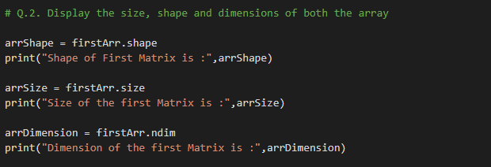

Output:

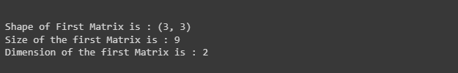

Q.3. Change the shape of First array. All the values must be fit into two rows.

